Process Synchronization

- To introduce the critical-section problem, whose solutions can be used to ensure the consistency of shared data
- To present both software and hardware solutions of the critical-section problem
- To introduce the concept of an atomic transaction and describe mechanisms to ensure atomicity

- Concurrent access to shared data may result in data inconsistency
- Maintaining data consistency requires mechanisms to ensure the orderly execution of cooperating processes
- Suppose that we wanted to provide a solution to the consumer-producer problem that fills all the buffers. We can do so by having an integer count that keeps track of the number of full buffers. Initially, count is set to 0. It is incremented by the producer after it produces a new buffer and is decremented by the consumer after it consumes a buffer

Producer

while (true) {

/* produce an item and put in nextProduced */
while (count == BUFFER_SIZE)
; // do nothing
buffer [in] = nextProduced;
in = (in + 1) % BUFFER_SIZE;
count++;
}
Consumer
while (true) {
while (count == 0)
; // do nothing
nextConsumed = buffer[out];
out = (out + 1) % BUFFER_SIZE;
count--;

/* consume the item in nextConsumed
}
Race Condition
count++ could be implemented as
register1 = count
register1 = register1 + 1
count = register1
count-- could be implemented as
register2 = count
register2 = register2 - 1
count = register2
Consider this execution interleaving with “count = 5” initially:
S0: producer execute register1 = count {register1 = 5}
S1: producer execute register1 = register1 + 1 {register1 = 6}
S2: consumer execute register2 = count {register2 = 5}
S3: consumer execute register2 = register2 - 1 {register2 = 4}
S4: producer execute count = register1 {count = 6 }
S5: consumer execute count = register2 {count = 4}
Solution to Critical-Section Problem

1. Mutual Exclusion - If process Pi is executing in its critical section, then no other processes can be executing in their critical sections
2. Progress - If no process is executing in its critical section and there exist some processes that wish to enter their critical section, then the selection of the processes that will enter the critical section next cannot be postponed indefinitely
3. Bounded Waiting - A bound must exist on the number of times that other processes are allowed to enter their critical sections after a process has made a request to enter its critical section and before that request is granted
Assume that each process executes at a nonzero speed
No assumption concerning relative speed of the N processes

Peterson’s Solution

- Two process solution
- Assume that the LOAD and STORE instructions are atomic; that is, cannot be interrupted.
- The two processes share two variables:
- int turn;
- Boolean flag[2]
- The variable turn indicates whose turn it is to enter the critical section.
- The flag array is used to indicate if a process is ready to enter the critical section. flag[i] = true implies that process Pi is ready!
Algorithm for Process Pi
do {
flag[i] = TRUE;
turn = j;
while (flag[j] && turn == j);
critical section
flag[i] = FALSE;
remainder section
} while (TRUE);

Synchronization Hardware

- Many systems provide hardware support for critical section code
- Uniprocessors – could disable interrupts
- Currently running code would execute without preemption
- Generally too inefficient on multiprocessor systems
Operating systems using this not broadly scalable
- Modern machines provide special atomic hardware instructions
Atomic = non-interruptable
- Either test memory word and set value Or swap contents of two memory words

Solution to Critical-section Problem Using Locks
do {
acquire lock
critical section
release lock
remainder section
} while (TRUE);

TestAndSet Instruction
Definition:

boolean TestAndSet (boolean *target)
{
boolean rv = *target;
*target = TRUE;
return rv:
}

Solution using TestAndSet

Shared boolean variable lock., initialized to false.
Solution:

do {
while ( TestAndSet (&lock ))
; // do nothing

// critical section

lock = FALSE;

// remainder section

} while (TRUE);

Swap Instruction

Definition:

void Swap (boolean *a, boolean *b)
{
boolean temp = *a;
*a = *b;
*b = temp:
}

Solution using Swap

Shared Boolean variable lock initialized to FALSE; Each process has a local Boolean variable key
Solution:
do {
key = TRUE;
while ( key == TRUE)
Swap (&lock, &key );

// critical section

lock = FALSE;

// remainder section

} while (TRUE);

Bounded-waiting Mutual Exclusion with TestandSet()
do {
waiting[i] = TRUE;
key = TRUE;
while (waiting[i] && key)
key = TestAndSet(&lock);
waiting[i] = FALSE;
// critical section
j = (i + 1) % n;
while ((j != i) && !waiting[j])
j = (j + 1) % n;
if (j == i)
lock = FALSE;
else
waiting[j] = FALSE;
// remainder section
} while (TRUE);

Semaphore
- Synchronization tool that does not require busy waiting
- nSemaphore S – integer variable
- Two standard operations modify S: wait() and signal()
- Originally called P() and V()
- Less complicated
- Can only be accessed via two indivisible (atomic) operations
wait (S) {
while S <= 0
; // no-op
S--;
}
signal (S) {
S++;
}

Semaphore as General Synchronization Tool

- Counting semaphore – integer value can range over an unrestricted domain
- Binary semaphore – integer value can range only between 0
and 1; can be simpler to implement
- Also known as mutex locks
- nCan implement a counting semaphore S as a binary semaphore
- Provides mutual exclusion
Semaphore mutex; // initialized to
do {
wait (mutex);
// Critical Section
signal (mutex);
// remainder section
} while (TRUE);

Semaphore Implementation
- Must guarantee that no two processes can execute wait () and signal () on the same semaphore at the same time
- Thus, implementation becomes the critical section problem where the wait and signal code are placed in the crtical section.
- Could now have busy waiting in critical section implementation
But implementation code is short
Little busy waiting if critical section rarely occupied
- Note that applications may spend lots of time in critical sections and therefore this is not a good solution.

Semaphore Implementation with no Busy waiting

- With each semaphore there is an associated waiting queue. Each entry in a waiting queue has two data items:
- value (of type integer)
- pointer to next record in the list

- Two operations:
- block – place the process invoking the operation on the appropriate waiting queue.
- wakeup – remove one of processes in the waiting queue and place it in the ready queue.

Implementation of wait:
wait(semaphore *S) {
S->value--;
if (S->value < 0) {
add this process to S->list;
block();
}
}
Implementation of signal:

signal(semaphore *S) {
S->value++;
if (S->value <= 0) {
remove a process P from S->list;
wakeup(P);
}
}

Deadlock and Starvation
- Deadlock – two or more processes are waiting indefinitely for an event that can be caused by only one of the waiting processes
- Let S and Q be two semaphores initialized to 1
P0 P1
wait (S); wait (Q);
wait (Q); wait (S);
.

. .
. .
signal (S); signal (Q);
signal (Q); signal (S);
- Starvation – indefinite blocking. A process may never be removed from the semaphore queue in which it is suspended
- Priority Inversion - Scheduling problem when lower-priority process holds a lock needed by higher-priority process

Classical Problems of Synchronization
- Bounded-Buffer Problem
- Readers and Writers Problem
- Dining-Philosophers Problem

Bounded-Buffer Problem

- N buffers, each can hold one item
- Semaphore mutex initialized to the value 1
- Semaphore full initialized to the value 0
- Semaphore empty initialized to the value N.

- The structure of the producer process

do {
// produce an item in nextp

wait (empty);
wait (mutex);

// add the item to the buffer

signal (mutex);
signal (full);
} while (TRUE);

The structure of the consumer process

do {
wait (full);
wait (mutex);

// remove an item from buffer to nextc

signal (mutex);
signal (empty);

// consume the item in nextc

} while (TRUE);

Readers-Writers Problem
A data set is shared among a number of concurrent processes
- Readers – only read the data set; they do not perform any updates
- Writers – can both read and write
- nProblem – allow multiple readers to read at the same time. Only one single writer can access the shared data at the same time

- Shared Data
- Data set
- Semaphore mutex initialized to 1
- Semaphore wrt initialized to 1
- Integer readcount initialized to 0

The structure of a writer process

do {
wait (wrt) ;

// writing is performed

signal (wrt) ;
} while (TRUE);

The structure of a reader process

do {
wait (mutex) ;
readcount ++ ;
if (readcount == 1)
wait (wrt) ;
signal (mutex)

// reading is performed

wait (mutex) ;
readcount - - ;
if (readcount == 0)
signal (wrt) ;
signal (mutex) ;
} while (TRUE);

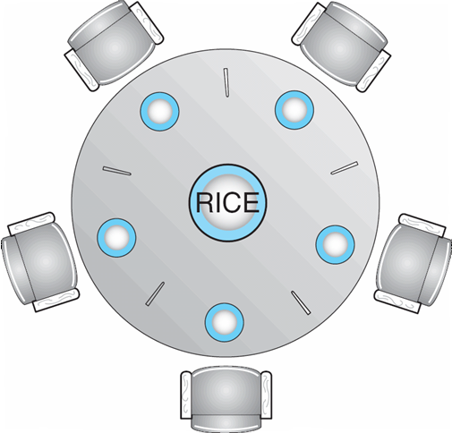
Dining-Philosophers Problem

- Shared data
- Bowl of rice (data set)
- Semaphore chopstick [5] initialized to 1

- The structure of Philosopher i:

do {
wait ( chopstick[i] );
wait ( chopStick[ (i + 1) % 5] );

// eat

signal ( chopstick[i] );
signal (chopstick[ (i + 1) % 5] );

// think

} while (TRUE);

Problems with Semaphores
Incorrect use of semaphore operations:

l signal (mutex)
….
wait (mutex)

wait (mutex) …
wait (mutex)

Omitting of wait (mutex) or signal (mutex) (or both)

Monitors
A high-level abstraction that provides a convenient and effective mechanism for process synchronization
Only one process may be active within the monitor at a time

monitor monitor-name
{
// shared variable declarations
procedure P1 (…) { …. }
…

procedure Pn (…) {……}

Initialization code ( ….) { … }
…
}
}
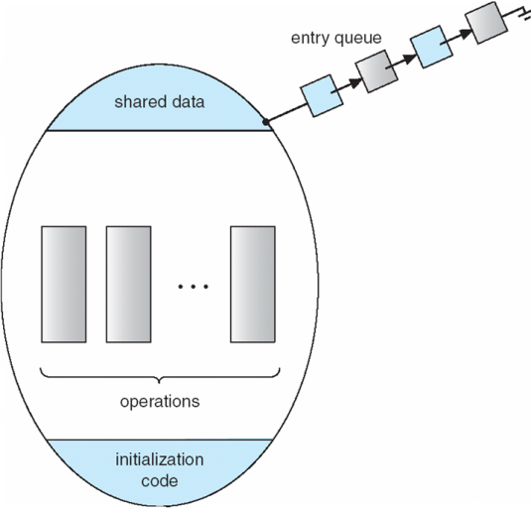
Schematic view of a Monitor

Condition Variables

condition x, y;

Two operations on a condition variable:
x.wait () – a process that invokes the operation is
suspended.
x.signal () – resumes one of processes (if any) that
invoked x.wait ()
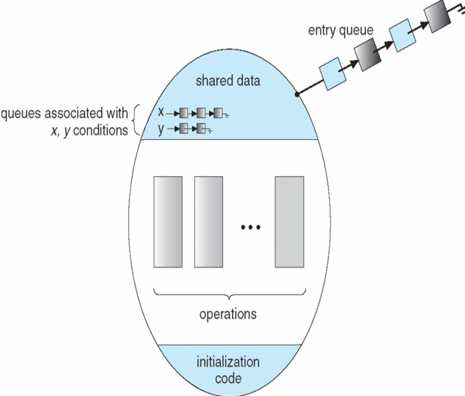
Monitor with Condition Variables

Solution to Dining Philosophers

monitor DP
{
enum { THINKING; HUNGRY, EATING) state [5] ;
condition self [5];

void pickup (int i) {
state[i] = HUNGRY;
test(i);
if (state[i] != EATING) self [i].wait;
}

void putdown (int i) {
state[i] = THINKING;
// test left and right neighbors
test((i + 4) % 5);
test((i + 1) % 5);
}

void test (int i) {
if ( (state[(i + 4) % 5] != EATING) &&
(state[i] == HUNGRY) &&
(state[(i + 1) % 5] != EATING) ) {
state[i] = EATING ;
self[i].signal () ;
}
}

initialization_code() {
for (int i = 0; i < 5; i++)
state[i] = THINKING;
}
}

Each philosopher I invokes the operations pickup()
and putdown() in the following sequence:

DiningPhilosophters.pickup (i);

EAT

DiningPhilosophers.putdown (i);

Monitor Implementation Using Semaphores

Variables
semaphore mutex; // (initially = 1)
semaphore next; // (initially = 0)
int next-count = 0;
nEach procedure F will be replaced by

wait(mutex);
…
body of F;

…
if (next_count > 0)
signal(next)
else
signal(mutex);
nMutual exclusion within a monitor is ensured.

Monitor Implementation
For each condition variable x, we have:

semaphore x_sem; // (initially = 0)
int x-count = 0;
nThe operation x.wait can be implemented as:

x-count++;
if (next_count > 0)
signal(next);
else
signal(mutex);
wait(x_sem);
x-count--;

The operation x.signal can be implemented as:

if (x-count > 0) {
next_count++;
signal(x_sem);
wait(next);
next_count--;
}
A Monitor to Allocate Single Resource
monitor ResourceAllocator
{
boolean busy;
condition x;
void acquire(int time) {
if (busy)
x.wait(time);
busy = TRUE;
}
void release() {
busy = FALSE;
x.signal();
}
initialization code() {
busy = FALSE;
}
}

Synchronization Examples
- Solaris
- Windows XP
- Linux
- Pthreads

Solaris Synchronization
- Implements a variety of locks to support multitasking, multithreading (including real-time threads), and multiprocessing
- Uses adaptive mutexes for efficiency when protecting data from short code segments
- Uses condition variables and readers-writers locks when longer sections of code need access to data
- Uses turnstiles to order the list of threads waiting to acquire either an adaptive mutex or reader-writer lock

Windows XP Synchronization

- Uses interrupt masks to protect access to global resources on uniprocessor systems
- Uses spinlocks on multiprocessor systems
- Also provides dispatcher objects which may act as either mutexes and semaphores
- Dispatcher objects may also provide events
- An event acts much like a condition variable

Linux Synchronization

- Linux:
- lPrior to kernel Version 2.6, disables interrupts to implement short critical sections
- Version 2.6 and later, fully preemptive

- Linux provides:
- semaphores
- spin locks

Pthreads Synchronization
- Pthreads API is OS-independent
- It provides:
- mutex locks
- condition variables
- nNon-portable extensions include:
- read-write locks
- spin locks

Atomic Transactions
- System Model
- Log-based Recovery
- Checkpoints
- Concurrent Atomic Transactions

System Model
- Assures that operations happen as a single logical unit of work, in its entirety, or not at all
- Related to field of database systems
- Challenge is assuring atomicity despite computer system failures
- Transaction - collection of instructions or operations that performs single logical function
- Here we are concerned with changes to stable storage – disk
- Transaction is series of read and write operations
- Terminated by commit (transaction successful) or abort (transaction failed) operation Aborted transaction must be rolled back to undo any changes it performed

Types of Storage Media
- Volatile storage – information stored here does not survive system crashes
- Example: main memory, cache
- Nonvolatile storage – Information usually survives crashes
- Example: disk and tape
- Stable storage – Information never lost
- Not actually possible, so approximated via replication or RAID to devices with independent failure modes

- Goal is to assure transaction atomicity where failures cause loss of information on volatile storage

Log-Based Recovery
- Record to stable storage information about all modifications by a transaction
- Most common is write-ahead logging
- Log on stable storage, each log record describes single transaction write operation, including
Transaction name
Data item name
Old value
New value
- <Ti starts> written to log when transaction Ti starts
- <Ti commits> written when Ti commits
- Log entry must reach stable storage before operation on data occurs

Log-Based Recovery Algorithm
Using the log, system can handle any volatile memory errors
- Undo(Ti) restores value of all data updated by Ti
- Redo(Ti) sets values of all data in transaction Ti to new values
- Undo(Ti) and redo(Ti) must be idempotent
- Multiple executions must have the same result as one execution
- If system fails, restore state of all updated data via log
- If log contains <Ti starts> without <Ti commits>, undo(Ti)
- If log contains <Ti starts> and <Ti commits>, redo(Ti)

Checkpoints
Log could become long, and recovery could take long
Checkpoints shorten log and recovery time.
Checkpoint scheme:
1.Output all log records currently in volatile storage to stable storage
2.Output all modified data from volatile to stable storage
3.Output a log record <checkpoint> to the log on stable storage
Now recovery only includes Ti, such that Ti started executing before the most recent checkpoint, and all transactions after Ti All other transactions already on stable storage

Concurrent Transactions

- Must be equivalent to serial execution – serializability
- Could perform all transactions in critical section
- Inefficient, too restrictive
- Concurrency-control algorithms provide serializability

Serializability

- Consider two data items A and B
- Consider Transactions T0 and T1
- Execute T0, T1 atomically
- Execution sequence called schedule
- Atomically executed transaction order called serial schedule
- For N transactions, there are N! valid serial schedules

Schedule 1: T0 then T1

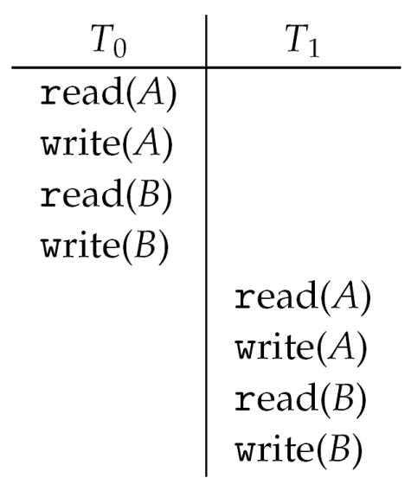

Nonserial Schedule

- Nonserial schedule allows overlapped execute
- Resulting execution not necessarily incorrect
- Consider schedule S, operations Oi, Oj
- Conflict if access same data item, with at least one write
- If Oi, Oj consecutive and operations of different transactions & Oi and Oj don’t conflict
- Then S’ with swapped order Oj Oi equivalent to S
- If S can become S’ via swapping nonconflicting operations
- S is conflict serializable

Schedule 2: Concurrent Serializable Schedule

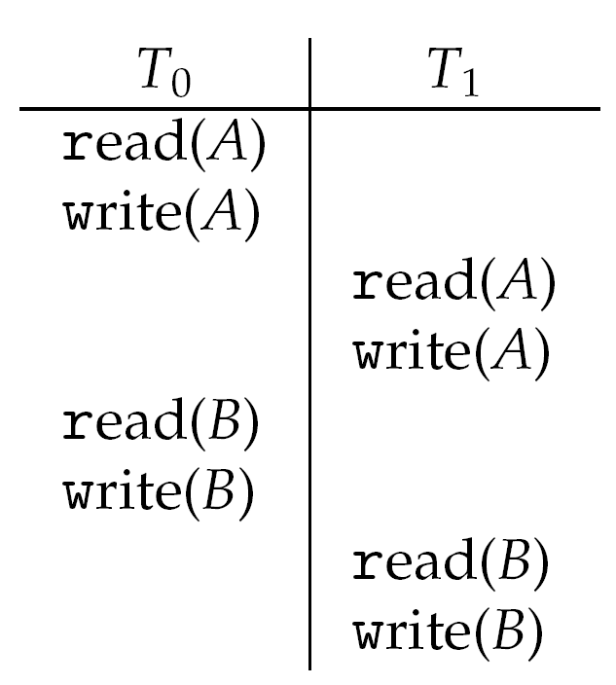

Locking Protocol

- Ensure serializability by associating lock with each data item
- Follow locking protocol for access control
- Locks
- Shared – Ti has shared-mode lock (S) on item Q, Ti can read Q but not write Q
- Exclusive – Ti has exclusive-mode lock (X) on Q, Ti can read and write Q
- Require every transaction on item Q acquire appropriate lock
- If lock already held, new request may have to wait
- Similar to readers-writers algorithm

Two-phase Locking Protocol

- Generally ensures conflict serializability
- Each transaction issues lock and unlock requests in two phases
- Growing – obtaining locks
- Shrinking – releasing locks
- Does not prevent deadlock

Timestamp-based Protocols

- Select order among transactions in advance – timestamp-ordering
- Transaction Ti associated with timestamp TS(Ti) before Ti starts
- TS(Ti) < TS(Tj) if Ti entered system before Tj
- TS can be generated from system clock or as logical counter incremented at each entry of transaction
- Timestamps determine serializability order
- If TS(Ti) < TS(Tj), system must ensure produced schedule equivalent to serial schedule where Ti appears before Tj

Timestamp-based Protocol Implementation

- Data item Q gets two timestamps
- W-timestamp(Q) – largest timestamp of any transaction that executed write(Q) successfully
- R-timestamp(Q) – largest timestamp of successful read(Q)
- Updated whenever read(Q) or write(Q) executed
- Timestamp-ordering protocol assures any conflicting read and write executed in timestamp order
Suppose Ti executes read(Q)
- If TS(Ti) < W-timestamp(Q), Ti needs to read value of Q that was already overwritten
read operation rejected and Ti rolled back
- If TS(Ti) ≥ W-timestamp(Q)
read executed, R-timestamp(Q) set to max(R-timestamp(Q), TS(Ti))

Timestamp-ordering Protocol

Supose Ti executes write(Q)
If TS(Ti) < R-timestamp(Q), value Q produced by Ti was needed previously and Ti assumed it would never be produced
Write operation rejected, Ti rolled back
If TS(Ti) < W-tiimestamp(Q), Ti attempting to write obsolete value of Q
Write operation rejected and Ti rolled back
Otherwise, write executed
Any rolled back transaction Ti is assigned new timestamp and restarted
Algorithm ensures conflict serializability and freedom from deadlock

Schedule Possible Under Timestamp Protocol

